**WhatABook**

**TECHNICAL DESIGN DOCUMENT**

|  |  |
| --- | --- |
| **Author** | ***Carl Logan & Chad ONeal*** |
| **Last Updated** | **11/29/2022 1:40PM** |
| **Version Number** | ***1.0.0*** |

**Version History**

|  |  |  |  |
| --- | --- | --- | --- |
| **Name** | **Date** | **Reason for Change** | **Version** |
| ***Chad & Carl*** | ***11/29/2022*** | ***New document format*** | ***1.0.0*** |
| ***Chad & Carl*** | ***12/09/2022*** | ***Adding ORD, NoSQL Data Structure, and DB queries.*** | ***1.1.0*** |
| ***Chad & Carl*** | ***12/13/2022*** | ***Adding final Queries and Python Application to complete project.*** | ***1.2.0*** |
|  |  |  |  |
|  |  |  |  |
|  |  |  |  |
|  |  |  |  |
|  |  |  |  |
|  |  |  |  |
|  |  |  |  |

**Table of Contents**

SECTION 1: INTRODUCTION 3

1.1. Team Introduction: - Hufflepuff 3

Carl Logan Co-Captain 4

Chad ONeal Co-Captain 5

1.2. Goals of the website 6

1.3. Core Users of the website revealed 6

SECTION 2: PROCESS DESIGN 13

2.1. Prototypes 13

2.2. ORD (Object Relational Diagram) 13

2.3. NoSQL Data Structures 14

2.4. Database Queries 16

SECTION 4: REFERENCES 19

# SECTION 1: INTRODUCTION

## 1.1. Team Introduction: - Hufflepuff

Meaning behind the Team Name and Mascot – As we are both huge fans of the Harry Potter series and our group was selected for us as if to be selected by the Sorting Hat, we decided to adopt the name of Hufflepuff and incorporate the mascot as well. Our only wish is that Hermoine could be on our team. Like Hermoine and Hufflepuff, we value hard work, dedication, patience and loyalty so our team's name and the mascot fit the bill.



## Carl Logan Co-Captain

Design became a curiosity in college when I started designing t-shirts for the different student organizations around campus. It soon turned into a business offering graphics and screen-printed products. After a decade the business was sold, and I moved into mechanical design. Experience in structural and civil design followed along with spare time spent learning furniture and sign design. All these disciplines have lent a bit of knowledge to create better designs in whatever I'm doing now. Right now, I'm in school studying computer science and web development in the hope of becoming the well-rounded designer I saw myself as a long time ago.



## Chad ONeal Co-Captain

I’m a student at Bellevue University and will be graduating in May 2023. I’ve been a salesperson for the past 18 years, yet I have made a career change into the world of web-development. I have experience working with HTML5, CSS3, JavaScript, Node.js, & NoSQL. I am studying to be a Full Stack Developer, yet my passion is Back-End Development. I love the creative aspect of web-design as I am a songwriter in my spare time as well. My side projects will be under my own undertaking with Wicked Robot Designs. I established this company in 2022 and I am looking to further my skill set under this brand name as well as to hopefully become a part of a larger development team that can provide more insight and direction.

## 1.2. Goals of the website

1. Establish an app to allow customers to browse in-store book listings.
2. Allow customers to add books to a wish list.
3. Allow customers to view their wish list.
4. Show a list of books by genre.
5. Show listing of books by author.
6. Search for a book by title.
7. Search for a book by ID.
8. Display wish list by customer ID.
9. Make the app as simple as possible (Krasso, n.d.).

## 1.3. Core Users of the website revealed

Middle aged clientele who only have minimal computer experience.

**1.4 User Personas**

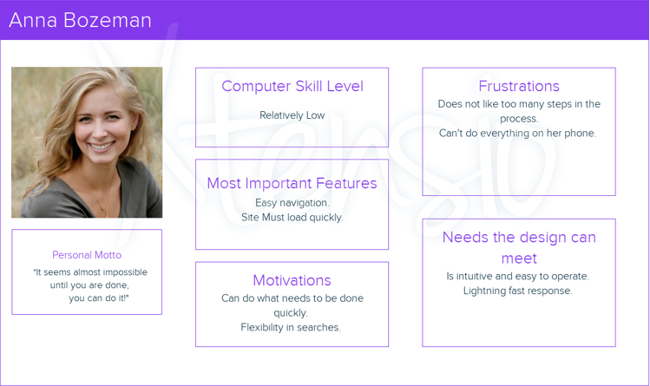

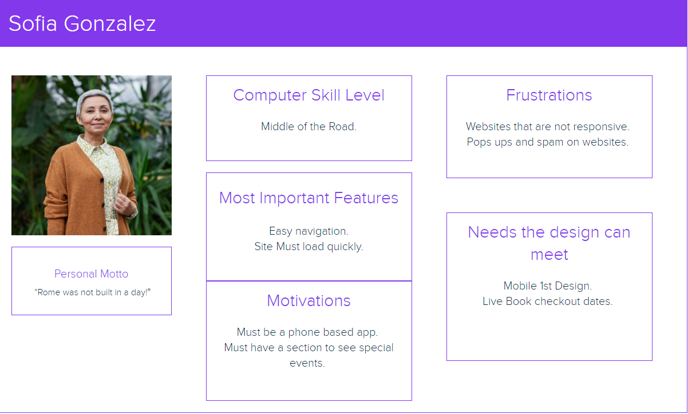

**1.5 User Stories**

Anna Bozman

1. As an api user, I need to be able to easily navigate the site, so that I can find what I need without frustration.
2. As an api user, I need to be able to be able to use my phone, so that I use the whatabook app on the go.
3. As an api user, I need to be able to access the site quickly, so that I can save time looking for what I want within the whatabook app.
4. As an api user, I need to be able to use the app in the most simplistic manner, so that I can properly perform all actions with the greatest of ease.
5. As an api user, I need to be able to have flexibility in my searches, so that I can perform one than one search criteria at once.

Sofia Gonzalez

1. As an api user, I need to be able to have a responsive search, so that I will not waste time with a site that does not perform like it should.
2. As an api user, I need to be able to see special events, so that I know when my favorite books are on sale.
3. As an api user, I need to be able to be abl3 to use the site without very little effort to not get confused.
4. As an api user, I need to be able to have less features, so that I can be less overwhelmed with choices.
5. As an api user, I need to be able to load the site quickly, so that I can find the book I want before I forget.

Marco Costanza

1. As a super user, I need to be able to fully understand the features, so that I can use the system to its fullest.
2. As a super user, I need to be able to easily use application features, so that I can perform quick accurate searches.
3. As a super user, I need to be able to use the application from many devices, so that I can make use of the service in all situations.
4. As a super user, I need to be able to list books using different criteria, so that I can stay organized.
5. As a super user, I need to be able to access the device on many different devices, so that I can be efficient in my searches no matter where I am at.

**1.6 Story Points**

|  |  |  |  |  |  |  |
| --- | --- | --- | --- | --- | --- | --- |
| **Story**    Anna Bozeman – API User | | | | | | |
| **Task** | | **Work Hours** | | | **Points** | |
| 1. Add a navigation feature that is very easy to see and use. | | 8 | | | 3 | |
| 1. Make sure to make the site responsive according to different demographics (especially smartphones). | | 16 | | | 7 | |
| 1. Make sure that the website is set up properly on the server and is routed correctly so that it runs very quickly. | | 10 | | | 5 | |
| 1. Make sure that the site is simplistic in nature, avoiding any unnecessary buttons or features that will confuse the user. | | 16 | | | 7 | |
| 1. Ensure the search function has a method to search by genre. | | 5 | | | 3 | |
| **Total Required:** | | **55 hours** | | | **25 points** | |
| Hours to Points Conversion | | | | | | |
| **(1-4** Hours**) = 1** Point | **(4-8** Hours**) = 3** Points | | **(8-16** Hours**) = 5** Points | **(16-24** Hours**) = 7** Points | | **(24+** Hours**) = 9** Points |

|  |  |  |  |  |  |  |
| --- | --- | --- | --- | --- | --- | --- |
| **Story**    Sofia Gonzalez – API user | | | | | | |
| **Task** | | **Work Hours** | | | **Points** | |
| 1. Ensure that the site search functions are routed correctly and return the correct values quickly. | | 10 | | | 5 | |
| 1. Add a function to be able to see special events. | | 5 | | | 3 | |
| 1. Make sure that the site is simplistic in nature, avoiding any unnecessary buttons or features that will confuse the user. | | 12 | | | 5 | |
| 1. Ensure the site has a section for viewing and adding items to a wish list. | | 16 | | | 7 | |
| 1. Ensure the search function has multiple options (searching for books by ID or title.) | | 8 | | | 5 | |
| **Total Required:** | | **51 hours** | | | **25 points** | |
| Hours to Points Conversion | | | | | | |
| **(1-4** Hours**) = 1** Point | **(4-8** Hours**) = 3** Points | | **(8-16** Hours**) = 5** Points | **(16-24** Hours**) = 7** Points | | **(24+** Hours**) = 9** Points |

|  |  |  |  |  |  |  |
| --- | --- | --- | --- | --- | --- | --- |
| **Story**    Marco Costanza – Super User | | | | | | |
| **Task** | | **Work Hours** | | | **Points** | |
| 1. Use the least number of steps possible, eliminate clutter**.** | | 8 | | | 3 | |
| 1. Ensure the search function has a method to search by author. | | 5 | | | 3 | |
| 1. Ensure the database is not cluttered and is safe and secure. | | 2 | | | 1 | |
| 1. Ensure the database is accurate, to return infallible results. | | 16 | | | 7 | |
| 1. Make the user feel like they are in control. | | 2 | | | 1 | |
| **Total Required:** | | **33 hours** | | | **13 points** | |
| Hours to Points Conversion | | | | | | |
| **(1-4** Hours**) = 1** Point | **(4-8** Hours**) = 3** Points | | **(8-16** Hours**) = 5** Points | **(16-24** Hours**) = 7** Points | | **(24+** Hours**) = 9** Points |

# SECTION 2: PROCESS DESIGN

## 2.1. Prototypes

<https://marvelapp.com/prototype/67ib4ab/screen/89850132>



## 2.2. ORD (Object Relational Diagram)

## 

## 2.3. NoSQL Data Structures

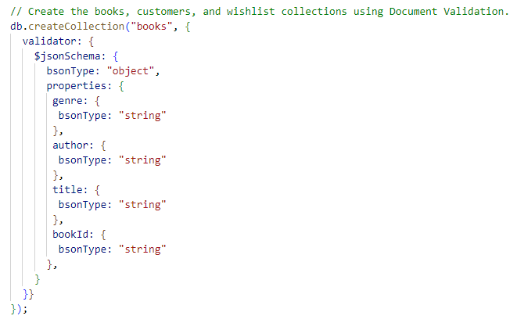

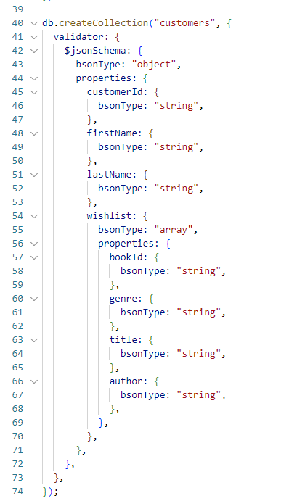

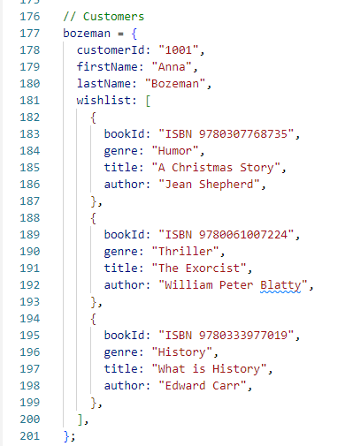

## 

## 2.4. Database Queries

//query to display a list of all books

db.books.find();

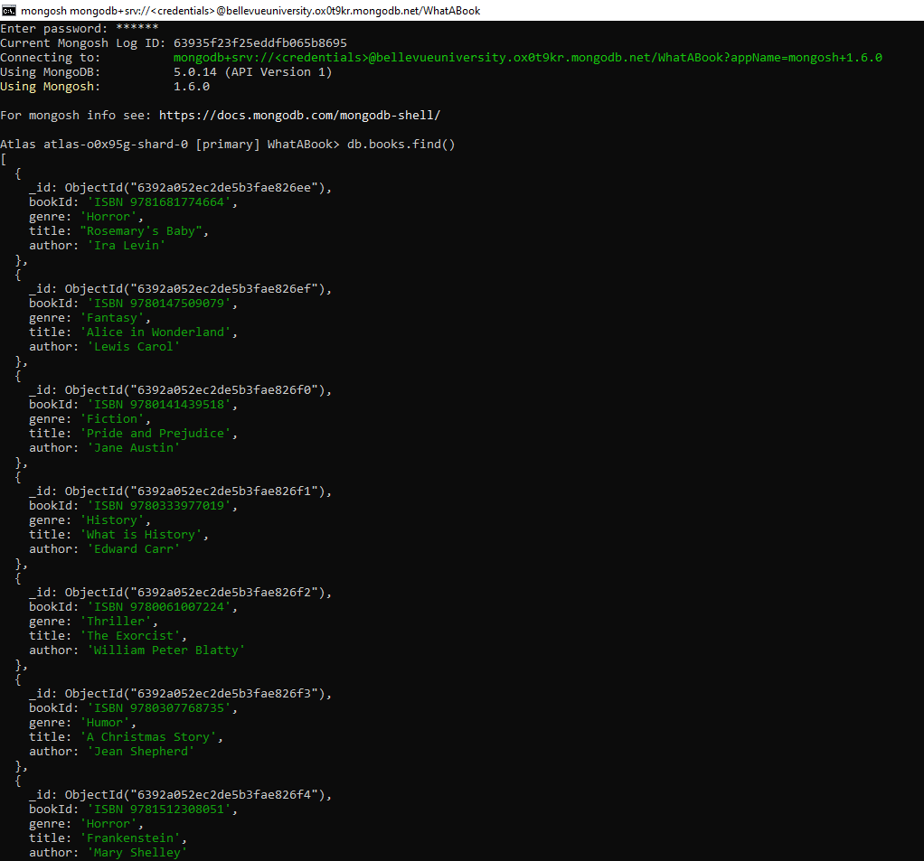

//query to display a list of books by genre

db.books.find({ "genre": "Horror"})

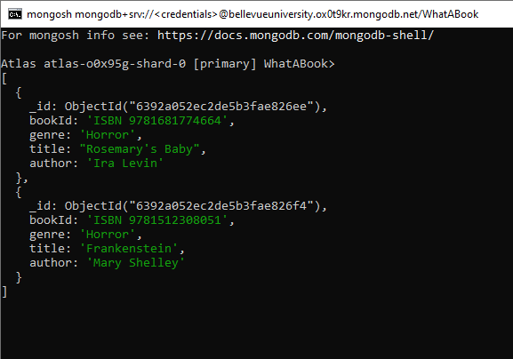

//query to display a list of books by author

db.books.find({ "author": "Ira Levin"})

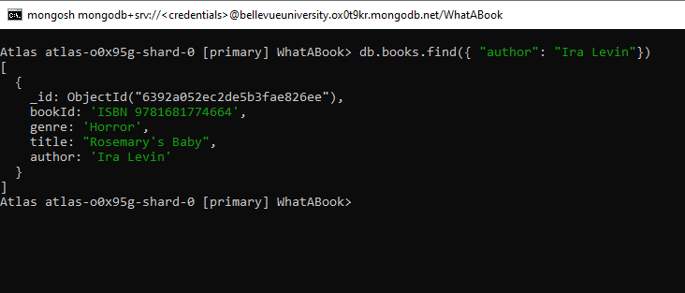

//query to display a book by bookId

db.books.find({ "bookId": "ISBN 9781543617672"})

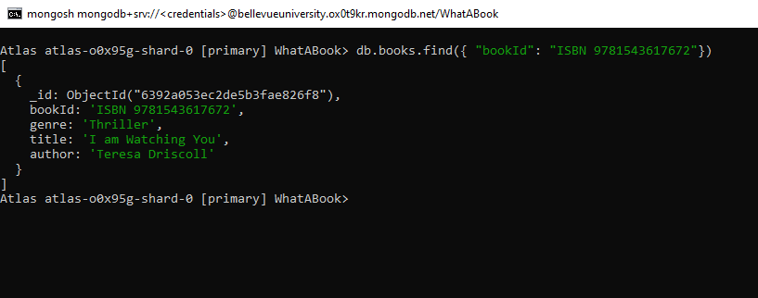

//query to display a wishlist by customerId

db.customers.find({ customerId: "1001" }, { wishlist: 1 })

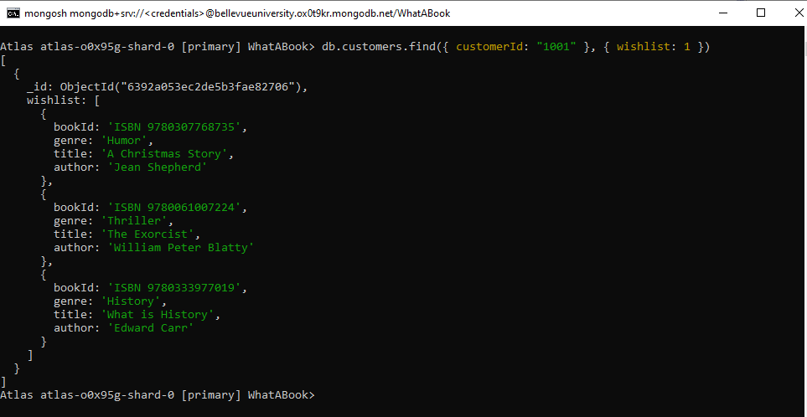

//add book to customers wishlistItems

db.customers.updateOne({ customerId: "1002" }, { $push: { "wishlist": { bookId: "ISBN 978-250268129", genre: "Humor", title: "The Panic Years", author: "Nell Frizzell"},},});

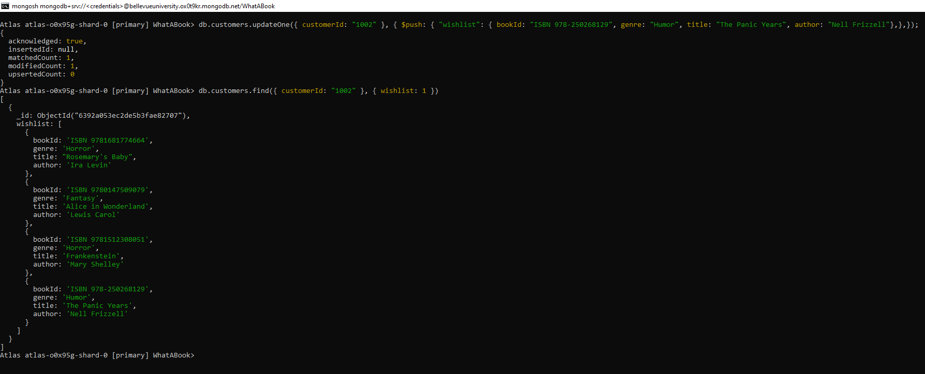

//remove a book from a customer's wishlist

db.customers.updateOne({ customerId: "1003" }, { $pull: {"wishlist": { title: "I am Watching You", genre: "Thriller", author: "Teresa Driscoll", bookId: "ISBN 9781543617672",},},});

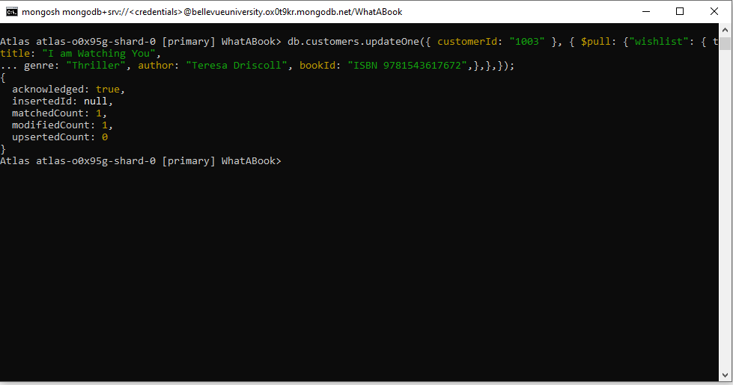

# SECTION 4: REFERENCES

Krasso, R. (n.d.). WhatABook Business Requirements. Document posted in Web 335: Introduction to NoSQL online classroom